

**ORCHESTRATE Dashboard User Guide**

**Accessing the ORCHESTRATE Dashboard(s)**

Please follow the instructions below to access dashboards. Users should receive an email from Tableau and/or Microsoft on this topic, but it is not necessary to click on these emails. Those are a formality to help get users to the correct sign on site, but the instructions below also get you there.

1. Navigate to the tableau single sign on (SSO) site: [**https://us-east-1.online.tableau.com/#/site/eversanaorchestrate/home**](https://us-east-1.online.tableau.com/#/site/eversanaorchestrate/home)

Add your EVERSANA email, check “remember me”, and hit **Sign In**

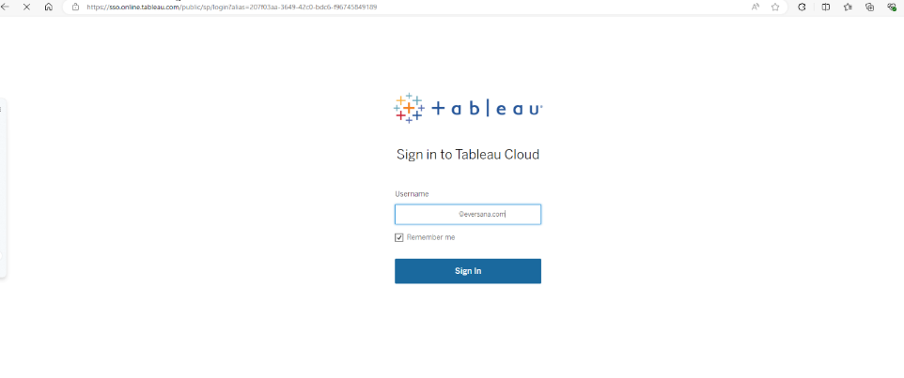

**If you are a first time EVERSANA Tableau Cloud user**, you will see one additional popup. Simply hit **Accept** to continue. You will not be asked this again.

If you are asked for a **URI**, please type in “eversanaorchestrate”.

1. Toggle to Eversana Orchestrate. From the home screen, you can click on the Explore Navigation to view the folders you have access to. Click on the folder for your account/brand and navigate to your dashboard.

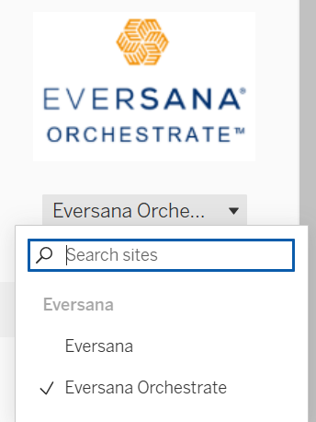

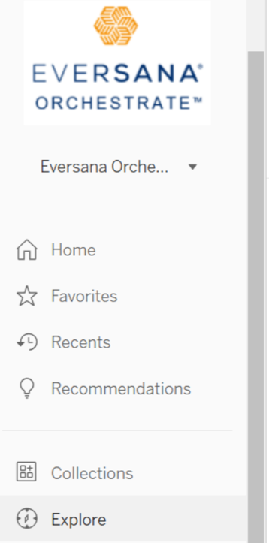

**TIP:** Once in your dashboard, bookmark the dashboard URL for easy access.